Jumbled Thoughts
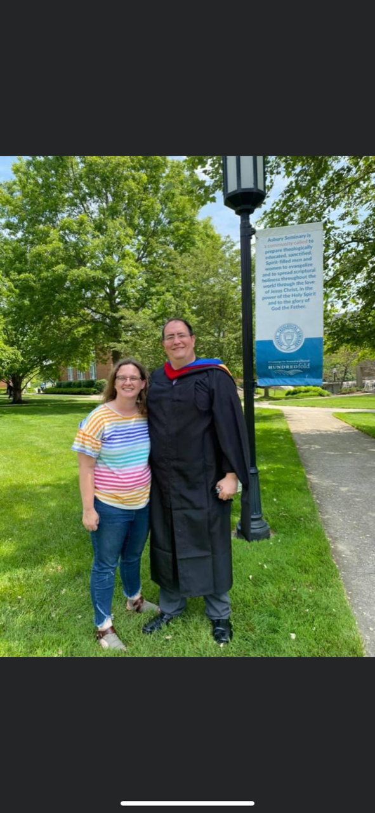
By Rev. Ryan Bachuss
July 31, 2022
Since I am going to be out of town this weekend, I thought I would give you some thoughts on how we tend to as pastors be workaholics. I would not qualify myself as such because Ido take breaks from time to time and I tend to take the whole day off Saturday unless I have a church event planned. I will confess that I was this way long before I started in the ministry though. Being a workaholic is not just a pastor thing though. We often tend to work ourselves more than we should. Whether it be in the gym, or at home, or at our jobs. It is important to realize that God gave us the Sabbath in order to restore our bodies, minds, and spirits. Without adequate rest, none of these parts will work as well as they should. So, my suggestion to everyone is to do what is necessary for your job, or your home, or your church, but remember to enjoy doing it and take your breaks when you need to. Enjoy having Kevin as our guest speaker this week as we return from our mini vacation. Have a blessed weekend everyone!

.
Bishop Mueller’s Daily Devotional
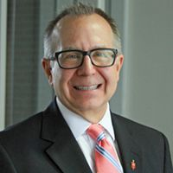

Blessings from God
Jul 31, 2020 | Bishop Mueller’s Daily Devotional
A beautiful sunrise. A baby’s smile. A beloved hymn. Seeing a loved one after a long absence. The joy you feel when you help someone who is struggling. A healthcare worker making sacrifices to care for those infected with Covid-19. A passage of scripture that speaks to your heart. These things – and so much more – are blessings from God. So the next time you wonder where God is in your life, just take a look around. You’ll have a hard time finding anywhere God is not.
I realize this is a replay but I thought about what Dorothy Dyer said during prayer time Sunday and this went well with that. Have a blessed weekend!

Our Mission Statement
C–-Create a community of trust & faith with our neighbors.
A---Attend to the physical needs of our neighbors.
P---Proclaim the Good News of Jesus Christ to our neighbors.

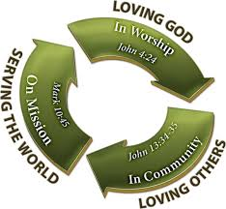
__________________________
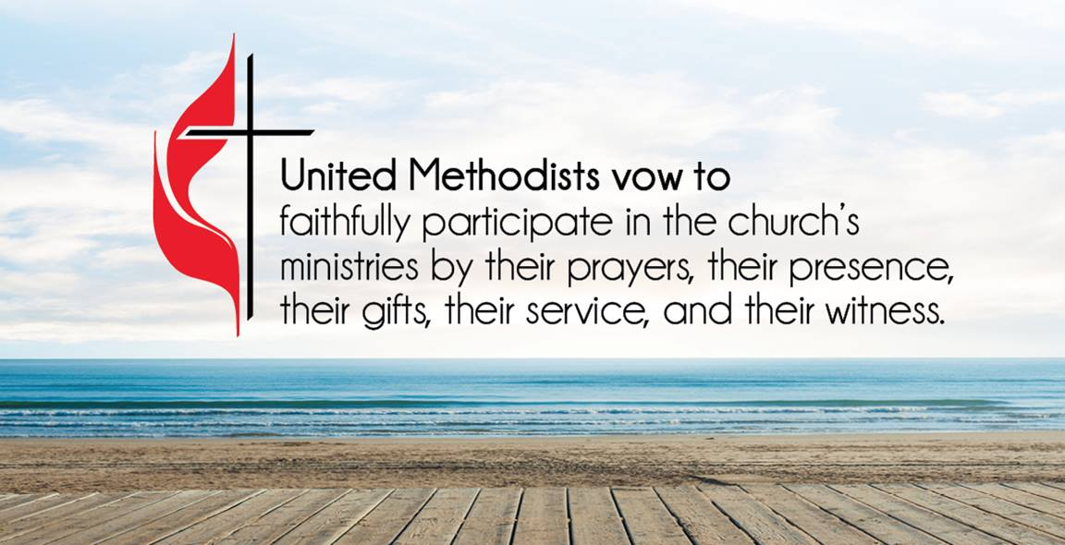
ATTENDANCE/STEWARDSHIP INFORMATION:
Sunday, July 24, 2022

Presley Chapel UMC
In Person Attendance = 31 Online Attendance = 2

General = $1,019.00 Building Fund = $0.00
Missions - $11.00
Mission Fund Balance = $1,401.57

Huntsville UMC
In Person Attendance = 40 Online Attendance = 1

General = $570.00 Building Fund = $0.00
Missions = $31.00
Mission Fund Balance = $1,473.62

How to continue supporting the church through your tithes and offerings…
Huntsville UMC:
To pay your tithes and offerings through PayPal, click on the following link: http://paypal.me/huntsvillearumc
Or, send your check to:
Huntsville UMC
P.O. Box 1257
Huntsville, Arkansas 72740
Presley Chapel:
Send check to:
Presley Chapel UMC
C/O Evelyn Ham
36872 Hwy 23
Huntsville, Arkansas 72740
______________________________

Birthdays & Anniversaries:

Presley Chapel UMC - Happy Birthday: Madison Cozad & Tasha Jackson - 31, Kevin Hatfield & Shelby Thompson - 6 Happy Anniversary:

Huntsville UMC - Happy Birthday: Patti White - 1, Jesse Coger - 2
Happy Anniversary: Gerald & Karla Van Brunt - 3, Dale & Therese Ramsey - 4

If you watch our service on Facebook, please comment or like us so that we can count your attendance.

METHODIST MEN'S CHICKEN PICK-UP:
We need your help! This is an easy way to participate in the ministries of our church. Takes less than two hours to complete. Pickup is at Tyson headquarters in Springdale at 8:00 a.m. on Tuesday mornings. Drop off at Open Arms food pantry. If you would like to help in this great cause, please click the new link and sign up or talk to pastor Ryan. https://www.signupgenius.com/go/10C0F4DAFAF29A4F4C34-chicken

______________________________

Coming this fall, we will be asking some of you all to be mentors for our confirmation classes. This will involve a short orientation class to help you understand what our goal is and to let you look over the material we will be studying. If you would like to volunteer to mentor one of our confirmands, please let me know and we will get a time set up to go over the details. It will involve no less than a 2 hour commitment each week and you will need to be prepared to answer questions and talk about your own confirmation experience. Thank you for considering this rewarding opportunity.
Youth taco dinner fundraiser coming in September. Stay tuned for the date and time.
If you have any small projects or any missional type activities for our youth to do, let Pastor Ryan know. We are looking for at least one local project for this summer.

Reminder to everyone, you have access to our online directory where you can update your photos or your address and phone information. Please keep our directory as updated as possible. If you have questions on how to access this directory, call us in the office.

Kevin Krest will be guest speaking this Sunday.

Sunday, August 28th at 6:00 p.m. Huntsville UMC is hosting a homemade ice cream contest. This is open to anyone who wants to participate and has a good ice cream recipe. Join us for a fun evening of judging and eating dessert.

"In the same way, the Spirit helps us in our weakness. We do not know what we ought to pray for, but the Spirit himself intercedes for us through wordless groans. And he who searches our hearts knows the mind of the Spirit because the Spirit intercedes for God’s people in accordance with the will of God."
Romans 8:26-27 New International Version (NIV)

family of Shawn McGlocklin, Gabby Gillham, Whitney Griffin, family of Rev. Dr. Autura Eason-Williams, Jerry Fritts, Chris Myers, Jerry B., Skyler Higgins, Jim Elmer, David Wood, Norma Bardow, Rachael Tishner, Sharron Croddy, Shannon Maupin, Kaye Doll

Our Military Members: JR Lievsay, Steven Davis, Owen Davis, John Commerford, Kimberly (Commerford) Gannott
Lord in your mercy, Hear our prayers…
Please email your prayer concerns to Pastor Ryan @ ryan.bachuss@arumc.org, huntsville@arumc.org, or presley.chapel@arumc.org.

Pastor Ryan’s prayer report:
David Wood is recovering at home now. Keep him in your prayers. Jerry Fritts as he is recovering from surgery. Denton Grubb would love to have visitors, he is in room 302 at Meadowview. Keep those dealing with Covid in your prayers as well.

Recipe of the Week
Leaving this for another week so everyone has a chance to get it.

Beef Stroganoff
2 cans mushroom soup, 1-8 oz cream cheese softened, 1 lb ground beef, ⅓ medium onion, ⅓ medium bell pepper, 1 ½ cups milk, 12 oz pkg egg noodles, salt and pepper.

Cook ground beef, onion and bell pepper together; salt and pepper to taste. Cook egg noodles to al dente. Mix cream cheese, soup, and milk together and add ground beef mixture. Stir until well mixed. Spray a 9x13 casserole dish with cooking spray and pour drained noodles in. Spread the cream cheese mixture on top of the noodles, covering them thoroughly. Preheat the oven to 375 and bake for an hour.

Children’s Corner
Wow! Summer is coming to an end. That means back to class for most of you. I hope you have enjoyed your summer break and feel ready for all the good stuff a new school year can bring. Know that God is with you as you get started, and that God will be with you always. Enjoy the last few weeks of summer break you have!

I hope you all have a blessed and happy summer and remember that God loves you and we love you and there is nothing you can do about it!

Youth News!
Be prepared for fun. Lots of new activity ideas are coming your way over the next few weeks.

July Events Calendar
Wednesday, July 6th: no youth Holiday week
Tuesday, July 26th: Meet at Huntsville fellowship hall 8:00 am to make lunches and go to the pantry. We will be there until around 11:30 then will meet for lunch TBD.
Wednesday, July 27th: cookout and water fun at the parsonage 6:00pm

All other weeks will be normal meeting at 6:00 in the youth room.
Youth will not meet on Wednesday, August 10th
Also, Wednesday, August 17th Youth will be at the fair to support our youth competitors in the livestock shows.
Jumbled Thoughts
By: Pastor Ryan
Wow! It is almost time for school to start back. I know you all love to be reminded of that. Something that always worried me growing up is whether I would be able to remember what I learned last year. There were certain things that were necessary to keep, such as math and english and even some of the history things. There were certain things we took because we had to, such as foriegn languages. Most of the important stuff as I called it was easy to remember, but the things that are only used for school, not so much. The same can be said of church, if you aren't there getting that refreshing feeling of being with other Christians, sometimes you start to lose some of it. That doesn't mean you forget how to be a christian, it just means that your batteries start to run low if you do not get filled back up often enough. Enjoy the last few weeks of summer break!

Church Staff
Rev. Ryan Bachuss, Pastor
Cell: (870)-918-1145
ryan.bachuss@arumc.org

Pam Villines, Administrative Assistant
huntsville@arumc.org
presley.chapel@arumc.org
Office: (479) 738-6890

Huntsville UMC
500 W. Main, Huntsville, AR 72740
Email: huntsville@arumc.org facebook.com/huntsvilleumc
www.huntsvillepresleychapelumc.org

Presley Chapel UMC
3091 Madison 1335, Huntsville, AR
Email: presley.chapel@arumc.org facebook.com/presleychapelumc
www.huntsvillepresleychapelumc.org
Office: (479) 738-6890

We need your news!
This page is to be reserved for good news. It is those stories that we are proud of. This can be church members or related, or it could just be wanting to brag on someone in the community. I want you to give us stories. This newsletter is for y’all, so be our reporters in the field.

