Jumbled Thoughts...
By Rev. Ryan Bachuss
October 17, 2021
“You do well if you really fulfill the royal law according to the scripture, You shall love your neighbor as yourself.” (James 2:8 NRSV) As I have mentioned before I struggle with the question who is your neighbor. I have neighbors here and they are mostly great. I have had times where my nearest neighbor was a mile away or just over that other ridge. But the neighbor that James talks about today is anyone you encounter. I have spoken about this before, but James puts it a bit differently. He says look at those around you and show no judgement. The person with rags on is just as important as the person wearing fine clothes and fancy jewelry. I am more apt to talk to the one wearing rags most of the time just because that is my personality. But what if the person who you are being asked to show no judgement against is an LSU or Texas fan or maybe even an Ole Miss fan? That is a hard one for me. Give me a trekkie or a Razorback fan and I'm good for days, but sometimes you have to be able to make friends with those who have little in common with you. It makes it easier to talk about what it's like to be a Christian if you look for some common ground even among those who you have difficulty finding that common ground with. So go out this week and talk to someone different than you and work to find the common ground even if they might be an LSU fan.

Bishop Mueller’s Daily Devotional

Bitsy

Oct 13, 2021 | Bishop Mueller’s Daily Devotional

We have a little Maltese named Bitsy (aka Little Bit). She is all of six pounds, ferociously protective when any car or stranger approaches the house, quick to warm up to strangers once she spends about 30 seconds with them and Karen’s shadow. It’s an interesting thing about Bitsy. When she’s allowed outside, she bounds off to explore the world; chasing everything from squirrels to Daddy Long Leg spiders (go figure) to sticks. But that’s not all. She also suddenly develops the inability to hear or, perhaps more to the point, chooses to ignore our commands that she performs so well inside. However, when we sit on the front porch and tether her with a 15 foot leash, something interesting happens. Sure, she still barks at anything that moves, including leaves blowing in front of her. But she seems perfectly content to walk around and explore her space that has boundaries. I think this is how it is with us. When we wander freely on our own, we often don’t hear (or more accurately ignore) Jesus when he speaks to us. But when we are tethered to Jesus, we have all the room we need, and actually are far more content and happy than we ever can be on our own.
Our Mission Statement
C—Create a community of trust & faith with our neighbors.
A---Attend to the physical needs of our neighbors.
P---Proclaim the Good News of Jesus Christ to our neighbors.

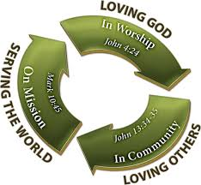
__________________________
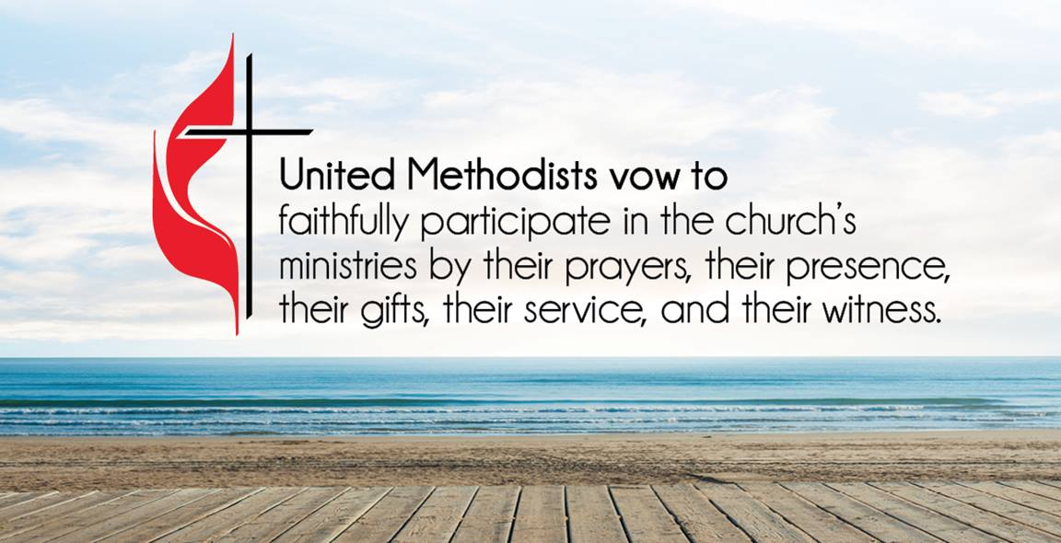
ATTENDANCE/STEWARDSHIP INFORMATION:
Sunday, October 10, 2021
Presley Chapel UMC
In Person Attendance = 25
Online Attendance = 7
General = $583.00
Building Fund = $0.00
Missions = $4.00

Huntsville UMC
In Person Attendance = 35
Online Attendance = 3
General = $1,040.00
Building Fund = $20.00
Missions = $14.00

How to continue supporting the church through your tithes and offerings…
Huntsville UMC:
To pay your tithes and offerings through PayPal, click on the following link: http://paypal.me/huntsvillearumc
Or, send your check to:
Huntsville UMC
P.O. Box 1257
Huntsville, Arkansas 72740
Presley Chapel:
Send check to:
Presley Chapel UMC
C/O Evelyn Ham
36872 Hwy 23
Huntsville, Arkansas 72740
______________________________
Birthdays & Anniversaries:
Presley Chapel UMC - Happy Birthday: Jim Dickinson - 17, Colleen Mitchell - 21 Happy Anniversary:

Huntsville UMC - Happy Birthday: Priscilla Griffin, Phil Atkinson, Kevin Wilson - 17
Happy Anniversary: Stephen & Patty Ford - 20

If you watch our service on Facebook, please comment or like us so that we can count your attendance.

METHODIST MEN'S CHICKEN PICK-UP:
We need your help! This is an easy way to participate in the ministries of our church. Takes less than two hours to complete. Pickup is at Tyson headquarters in Springdale at 8:00 a.m. on Tuesday mornings. Drop off at Open Arms food pantry. If you would like to help in this great cause, please click the new link and sign up or talk to pastor Ryan. https://www.signupgenius.com/go/10C0F4DAFAF29A4F4C34-chicken

The Eubanks family will be in concert at Huntsville UMC in the sanctuary on October 24th at 5:00 p.m. They sing a mix of bluegrass and southern gospel music and have a great ministry as they travel the region and bring their special blend of music to churches and events all over. This is a community event and we want you to tell your friends and fill the sanctuary for this special concert event. Let's work to bring fellowship back to the Church!

If you have an excess of children’s or under 18 books, please consider donating them to local youth and children. There will be a drop box in the entry way that you can leave books and we will distribute them to where they need to be. This is how we are participating in the yearly Ingathering. A new part of the 200,000 reasons program includes fighting illiteracy in Arkansas. Please join us in working on this project.
______________________________
Youth Meets every Wednesday night at 6:00 pm in the youth room at Huntsville UMC.

Eubanks Family in concert @ Huntsville UMC Sunday, October 24th @ 5:00 p.m. with reception to follow.

Men’s Breakfast @ Presley Chapel UMC Saturday, October 30th @ 8:00 a.m.

Presley Chapel 5th Sunday music service and Potluck October 31st

Charge Conference will be held via zoom on November 14th at 3:00 p.m. This will be a district wide charge conference. If you would like to be a part of the charge conference, please let me know so I can get you the zoom link. There will be a sign up sheet in the back of both sanctuaries. If you would like to watch the charge conference but do not have zoom access, we will have it on the screen in the sanctuary at Huntsville.

Huntsville UMC has a new Sunday School class. Pairs and Spares class begins at 10:00 a.m. on Sundays in the fellowship hall. Join us as you are for Sunday School.

Katherine Moore is leading a women’s Bible study every Wednesday night from 5:30 pm until 7:00 pm. The meeting is held in the Fellowship Hall at Huntsville United Methodist Church. Contact the church office at 479-738-6890 if you have any questions.

"In the same way, the Spirit helps us in our weakness. We do not know what we ought to pray for, but the Spirit himself intercedes for us through wordless groans. And he who searches our hearts knows the mind of the Spirit because the Spirit intercedes for God’s people in accordance with the will of God."
Romans 8:26-27 New International Version (NIV)

Kathleen Morris family, Pat Klinger, Kathy Burk, Ruth Matthews, Wes Honnell family, Chuck Hurburt, Sharon Kendrick, Sharon Daniels, Marie Hendricks family, Christy Jackson, Bobby Hawkins, our schools, our national, state, and local leaders, healthcare workers and all affected by COVID-19, Donald Lee & Sharon Kay Myers, Gabby Gillham, Jake Jacobson, Buddy Goudeau, Mary Bergman, Kaye Doll, Barry Cleaver, Les & Marlene Norton
Our Military Members: JR Lievsay, Steven Davis, Owen Davis, John Commerford, Kimberly (Commerford) Gannott

Lord in your mercy, Hear our prayers…

Please email your prayer concerns to Pastor Ryan @ ryan.bachuss@arumc.org, huntsville@arumc.org, or
presley.chapel@arumc.org.

Recipe of the week
Since it is getting cooler, I thought I would put my chili recipe out there. (just a note for Lyndsey...I did not put the one with the cinnamon in it).
3 lbs ground beef
1 medium onion chopped
1 bell pepper chopped
2 cans ranch style beans
1 can stewed tomatoes(do not drain)
1 can rotel (drained)
2 pkgs your favorite chili seasoning mix.
In a large soup pot, saute the onions, bell peppers, and ground beef until the meat is browned. Add in all other ingredients and stir well. Bring this mix to a boil, then add water to reach the desired thickness. I usually add a bit less water because I like a thicker chili. Simmer for at least 1 hour on low heat. The longer you let it simmer, the better the flavor. Serve with Fritos and shredded cheese.

*If you would like to submit a recipe please email to huntsville@arumc.org or ryan.bachuss@arumc.org or drop one off in person at the huntsville office.

It finally feels like fall y'all. This means that the leaves are starting to fall and the mornings require a jacket. The changing seasons remind me of how much our lives change. We go from not being able to tie our shoes to playing athletics in high school, to whatever our career ends up being. The best thing we can remember is God is with us through the changes in our lives. As we grow we come to appreciate this even more. Have a great week and enjoy the falling leaves and cooler weather.

ATTENTION Huntsville UMC kids...
K.I.D.S.Under Construction Zone!
OCTOBER BEGINS CHRISTMAS!!
Calling out K.I.D.S!!!!!
It’s time for Christmas!
OCTOBER 10, 2021
IT BEGINS!!!
We need your child to be a PUPPET, learn some music, LIGHTS, STAGE! ACTION!!
You can drop off downstairs at church for practice before you attend adult services either upstairs or going to outdoor service.
Children will not be upstairs during the adult services. Just have your child come downstairs before you sit down OR travel to outdoor area. Please note: have your child bring their own face masks--it will actually help us learn to project our voices.
Requirements:
Ages toddler through 5th grade--
Toddlers: will be given toddler parts-no puppets but in choir
Kindergarten-5th: will be puppeteers with music: rhythm & choir. Puppets have limited speaking parts.
K-5 need to attend ALL practices. Toddlers will learn their music and be free to play while K-5th are learning more complicated music/puppet movements.
Costumes: Puppeteers will need to be dressed in DARK clothing, dark jeans/leggings, dark tees
Questions? Ms. Karla’s text number: 479-790-1087

If you have an achievement that you would like to have mentioned here please let me know. We want to recognize you for your accomplishments.

Good Luck and our prayers to all of our students competing in the state fair this next two weeks!!
Youth News!

Youth Jumbled Thoughts
By Pastor Ryan
I was watching the leaves fall yesterday, and it made me think about the life cycle of a tree. These trees go dormant during the winter to conserve water, then when spring begins they fill up and the green leaves begin to appear and then they have all their flowering times which makes everyone sneeze then they just hang around all summer waiting for fall to come back so they can all fall off. Most of them end up as mulch somewhere. How awesome is it to think that our creator made plants that can-do things like that, they are self-sustaining? But humans are not. We need our families, we need our friends, we need the love and grace that God provides. We are the most amazing creation on the earth, yet God made us with a desire to know our creator, a desire to build relationships, a need to love others and feel loved. It is great to know that we are designed to love. Now just go out and do it to the best of your ability.

Church Staff
Rev. Ryan Bachuss, Pastor
Cell: (870)-918-1145
ryan.bachuss@arumc.org

Pam Villines, Administrative Assistant
huntsville@arumc.org
presley.chapel@arumc.org
Office: (479) 738-6890

__________________________

Huntsville UMC
500 W. Main, Huntsville, AR 72740
Email: huntsville@arumc.org facebook.com/huntsvilleumc
www.huntsvillepresleychapelumc.org

Presley Chapel UMC
3091 Madison 1335, Huntsville, AR
Email: presley.chapel@arumc.org facebook.com/presleychapelumc
www.huntsvillepresleychapelumc.org
Office: (479) 738-6890

