Jumbled Thoughts...
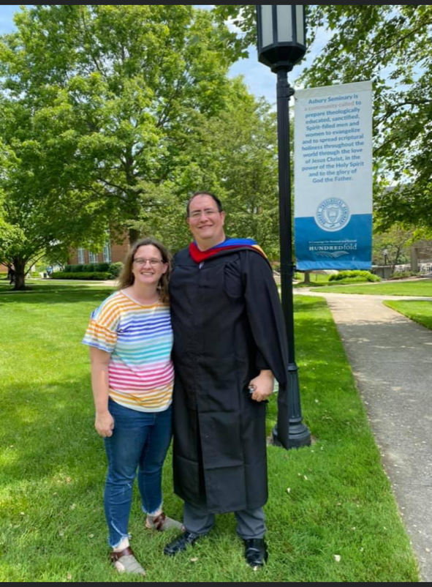
By Rev. Ryan Bachuss
November 28, 2021

More and more often I catch myself now wishing for peace. Sometimes it is peace at my house when Emerson is really loud and running crazy. Sometimes it is peace within my own heart when I feel like I am not doing my best. Sometimes it is peace in our country when I hear about another senseless shooting or another wasted life. But most of all I search for the peace that comes from knowing Christ Jesus as my savior. That type of peace is a forever one. No matter what is going on in my own head or in my own heart, no matter what the journey has led me to, I can continue to experience the peace of Christ in my life without having to dig too deep. I hope and pray that each one of you will experience that peace with me this week as we are beginning our advent journey together. This series is designed to guide us ever closer to Christ through reminding us of who we are as Christians. I hope you all had a great Thanksgiving and that your Advent season is one to remember.
My prayers are with you all.

Bishop Mueller’s Daily Devotional
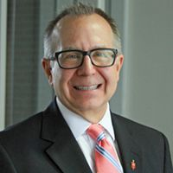

One Great Reason

Nov 22, 2021 | Bishop Mueller’s Daily Devotional

The fact of the matter is life is filled with bad people, painful experiences and suffering that seems to get worse and worse and worse. And no amount of pretending, denial or spin can change that. Which means there are lots of good reasons for you to be cynical, depressed and anxious about the future. However, there is one great reason to refuse to be sucked into a vortex of hopelessness. God. God who loves you more than you love yourself. God who manifests the fullness of that love by becoming human. God who seeks you out right in the middle of whatever is going on in your life and sticks to you like glue. God who has not, does not and will not give up on you. So when life threatens to smother you, turn to God who is already here with open arms.

Our Mission Statement
C—Create a community of trust & faith with our neighbors.
A---Attend to the physical needs of our neighbors.
P---Proclaim the Good News of Jesus Christ to our neighbors.

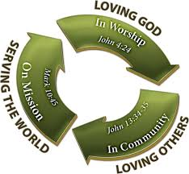
__________________________
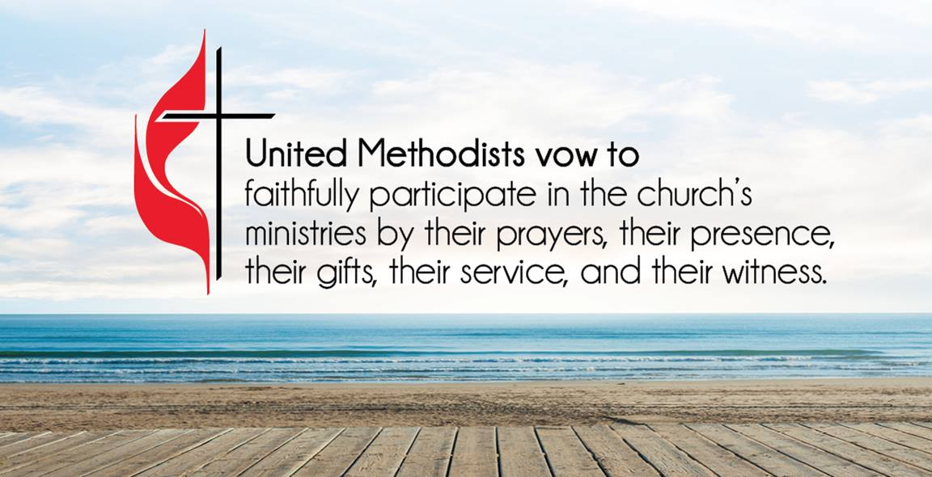
ATTENDANCE/STEWARDSHIP INFORMATION:
Sunday, November 21, 2021
Presley Chapel UMC
In Person Attendance = 30
Online Attendance = 5
General = $2,725.00
Missions = $31.00
Building Fund = $500.00

Huntsville UMC
In Person Attendance = 37
Online Attendance = 4
General = $845.00
Missions = $10.00
Building Fund = $20.00

How to continue supporting the church through your tithes and offerings…
Huntsville UMC:
To pay your tithes and offerings through PayPal, click on the following link: http://paypal.me/huntsvillearumc
Or, send your check to:
Huntsville UMC
P.O. Box 1257
Huntsville, Arkansas 72740
Presley Chapel:
Send check to:
Presley Chapel UMC
C/O Evelyn Ham
36872 Hwy 23
Huntsville, Arkansas 72740
______________________________

Birthdays & Anniversaries:
Presley Chapel UMC - Happy Birthday: Penny Gaskill - 3, Liz Law - 4 Happy Anniversary: Ryan & Lyndsey Bachuss - 3

Huntsville UMC - Happy Birthday: Jerry Doll - 2
Happy Anniversary: Andy & Katherine Moore - 30, Ryan & Lyndsey Bachuss - 3

If you watch our service on Facebook, please comment or like us so that we can count your attendance.

METHODIST MEN'S CHICKEN PICK-UP:
We need your help! This is an easy way to participate in the ministries of our church. Takes less than two hours to complete. Pickup is at Tyson headquarters in Springdale at 8:00 a.m. on Tuesday mornings. Drop off at Open Arms food pantry. If you would like to help in this great cause, please click the new link and sign up or talk to pastor Ryan. https://www.signupgenius.com/go/10C0F4DAFAF29A4F4C34-chicken

Confectioners and Bakers NEEDED
It’s time to get ready for the ANNUAL BAKE SALE!
We need YOUR cookies, candy, fudge, brownies and yummy things to sell on Parade Day!
Parade Day is Saturday, December 4th
Please Package and Price your items. $.50 to $1.50...or more, if you have a big item or pricey made item.
Bring your goodies to the church by 5pm, then stay for the parade!

______________________________

Huntsville UMC has a new Sunday School class. Pairs and Spares class begins at 10:00 a.m. on Sundays in the fellowship hall. Join us as you are for Sunday School.

Katherine Moore is leading a women’s Bible study every Wednesday night from 5:30 pm until 7:00 pm. The meeting is held in the Fellowship Hall at Huntsville United Methodist Church. Contact the church office at 479-738-6890 if you have any questions.

This year we are donating toys to local families who cannot afford Christmas presents. There are wreaths at the back of both sanctuaries with ornaments on them. Each ornament has a toy and a price range on it. Please bring your wrapped toy and the ornament back to the church by no later than December 16th for us to be able to get them to the schools for distribution.

"In the same way, the Spirit helps us in our weakness. We do not know what we ought to pray for, but the Spirit himself intercedes for us through wordless groans. And he who searches our hearts knows the mind of the Spirit because the Spirit intercedes for God’s people in accordance with the will of God."
Romans 8:26-27 New International Version (NIV)

Gaye Watson, Penny Gaskill, Jackie Brashears, Matt & Reyna Leffert, all who are traveling, Pat Klinger, Gabby Gillham, Kaye Doll, Beverly, family of DJ Booth, Kaine Doughty, missionaries in Haiti, those dealing with violence, Chuck Hurburt, Sharon Daniels, Bobby Hawkins, our schools, our national, state, and local leaders, healthcare workers and all affected by COVID-19, Donald Lee & Sharon Kay Myers, Jake Jacobson, Buddy Goudeau, Mary Bergman, Barry Cleaver, Les & Marlene Norton
Our Military Members: JR Lievsay, Steven Davis, Owen Davis, John Commerford, Kimberly (Commerford) Gannott

Lord in your mercy, Hear our prayers…

Please email your prayer concerns to Pastor Ryan @ ryan.bachuss@arumc.org, huntsville@arumc.org, or
presley.chapel@arumc.org.

Recipe of the Week

*If you would like to submit a recipe please email to huntsville@arumc.org or ryan.bachuss@arumc.org or drop one off in person at the Huntsville office.

This is my favorite Thanksgiving food.

Crockpot Dressing

5 ribs celery, chopped
1 box chicken broth
3 pkgs mexican cornbread, cooked according to label
1 small onion, chopped
3 eggs
2 cans cream of chicken soup
Salt and pepper to taste
I use rubbed sage, but you can use either one. I do not have a set amount for it either, it depends on how much you like sage.

Cook cornbread mix according to packet directions. Let cool, then break it up into small pieces. In a large crockpot, add cornbread, chopped onion, celery, 3 eggs, cream of chicken soup, and chicken broth. Stir this mixture well. Add the salt and pepper and sage. Stir again. Let cook on low for 4-5 hours. Do not re-stir after you start the mix.

Children’s Corner

Happy beginning of advent season! This is a time of anticipation. We are expecting Jesus to be born. We are expecting lots of presents. We are expecting candy and baked goods. Our expectations are high, but Jesus' birth overshadows them all. Feel blessed this season to know Jesus and enjoy all the goodies that come with Christmas.

Thanksgiving + Practice =
ONE PUPPET PLAY!
K.I.D.S. under construction Zone! During adult services each Sunday of November we are still practicing for the Christmas Play! Your hard work is paying off, the time is approaching for us to bring Christmas into every heart! Don’t forget, YOU are important! Downstairs practice EACH Sunday!

If you have an achievement that you would like to have mentioned here please let me know. We want to recognize you for your accomplishments.

Last week the youth spent their time building the Thanksgiving boxes that were distributed. I thank them for their hard work in getting them put together and we will continue to do service projects like that throughout the year.

Youth News!

Jumbled Thoughts
By Pastor Ryan
Warning today's topic is very preachy! Over the past several years, I have learned that life is never as simple as one would like it to be. As much as we would like it to be black and white, the world has given us many gray areas. These gray areas tend to cloud our ability to judge right from wrong. Look at how the world treats poverty, bullying and so many other things we all know as Christians to be wrong. That is why it is so important to have a sense of who you are. We are loved by God and since we are loved by God, we can love who we are and love God. If we do these two things then we can love our neighbors, and not just the ones next door. Once we know who we are the gray areas which cloud our judgement begin to go away and we can better understand right from wrong, and justice from injustice. Live in the light, avoid the gray areas and know that we are loved by God so we can love ourselves, God, and others. Remember that we are all children of God and therefore we need to see ourselves like God sees us, as children full of potential and love.

Just the Girls Having Lunch
Meeting Minutes
For Presley Chapel and Huntsville UMC

Sharing and Caring! For
Meadowview Residents
The stockings are ready!
We are gathering supplies to fill stockings for the residents at Meadowview Nursing Home. The stockings are ready to be filled, but we need help gathering the fun for the residents!
Please consider donating the following items:
60-Travel size or small lotion for men or women
60-Travel toothbrush and toothpaste
60-Combs
60-Brushes
60 Packages of Individual “purse” size tissues
60 pairs of socks
30 lap size fleece blankets (similar to the $3 - $5 ones)
If you want to help out purchasing these items, we need them before December 1st. We have to do some alterations to the blankets so they can be used with wheelchairs.

A BIG THANKS for our Stocking Sewing Girls!

PS> If you’re reading this article, please know that you don’t have to be attending the group to help out the Meadowview Residents. Just drop off your donations to Pam in the church office!

Church Staff
Rev. Ryan Bachuss, Pastor
Cell: (870)-918-1145
ryan.bachuss@arumc.org

Pam Villines, Administrative Assistant
huntsville@arumc.org
presley.chapel@arumc.org
Office: (479) 738-6890

__________________________

Huntsville UMC
500 W. Main, Huntsville, AR 72740
Email: huntsville@arumc.org facebook.com/huntsvilleumc
www.huntsvillepresleychapelumc.org

Presley Chapel UMC
3091 Madison 1335, Huntsville, AR
Email: presley.chapel@arumc.org facebook.com/presleychapelumc
www.huntsvillepresleychapelumc.org
Office: (479) 738-6890

