Jumbled Thoughts...
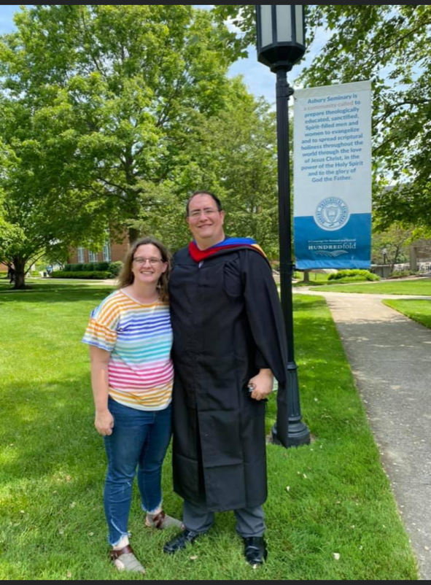
By Rev. Ryan Bachuss
May 15, 2022
This week we are looking at a passage of scripture that many of us are very familiar with. We are looking at the great commission from Matthew 28:16-20. It is a scripture that gives us all the task of going out into the world. There are some key parts of this text that we often forget to look at. First it doesn’t say go tell your friends and families about me, it says go unto all the world. That is an important statement because at first the disciples are hesitant to do so. Second it doesnt say you have two weeks to get all this done, there is no set timeline for what we are doing. Third, we get to see that Jesus did not abandon us at any point. He says he is with us to the end of the age. That is a promise that our lives depend on. That is Jesus saying I have given a task but I do not expect you to do it alone. Jesus then disappears from their sight in the Luke scripture and is taken up in a cloud in the MAtthew scripture. These events are recorded to guide us in our everyday walk of faith. We have an awesome opportunity to lead others to JEsus through our actions and words. We also know that we have all the tools we need to achieve that work. Lord fill our hearts to overflowing, so that we might reach others for you to fill as well. Amen!
Bishop Mueller’s Daily Devotional
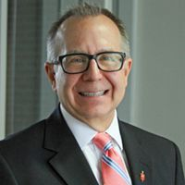

Sound Harsh?

May 10, 2022 | Bishop Mueller’s Daily Devotional

We are physical beings, created in the image of God, yet fallen. Far too often, we are overwhelmed by life and struggle to find hope. Yet Jesus, our Incarnated Savior and Lord, gives us what we need in the face of this reality but can never get on our own: salvation, healing, transformation, purpose, joy and hope. But look what we do with this greatest of all gifts we have received. We anoint Jesus as the great ideologue who embraces our worldview, raise him up as the standard-bearer of our political party, turn him into a club to beat those who disagree with us – especially other Christians, place him in a box so that he only addresses ‘spiritual’ issues and put him in our pocket to pull out when we need him to fix something the way we want it. Does this sound harsh? I suppose. But the question is not whether it seems harsh to our ears. It’s whether it contains truth which we have to deal with. And, ultimately, whether we are willing to take Jesus on his terms and not ours.
Our Mission Statement
C—Create a community of trust & faith with our neighbors.
A---Attend to the physical needs of our neighbors.
P---Proclaim the Good News of Jesus Christ to our neighbors.

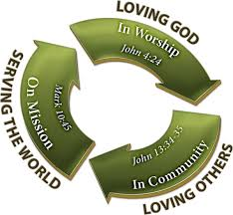
__________________________
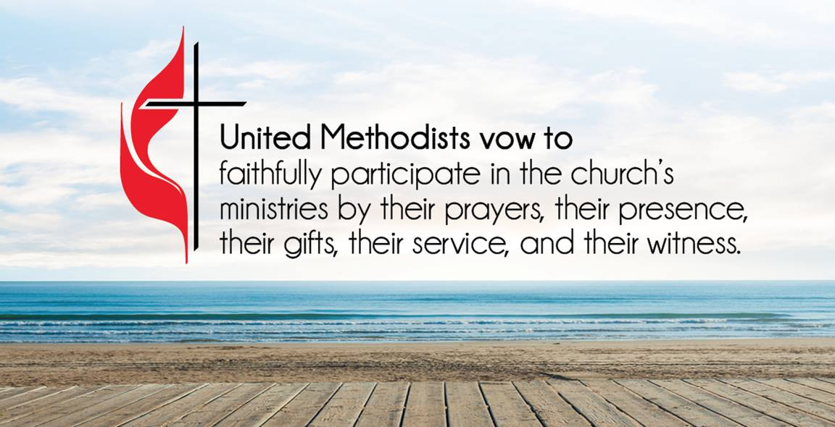
ATTENDANCE/STEWARDSHIP INFORMATION:
Sunday, May 8, 2022

Presley Chapel UMC
In Person Attendance = 44 Online Attendance = 3

General = $1,510.00 Building Fund = $0.00
Missions - $26.00
Mission Fund Balance = $1,074.10

Huntsville UMC
In Person Attendance = 32 Online Attendance = 0

General = $269.00 Building Fund = $0.00
Missions = $26.00
Mission Fund Balance = $1,716.55
Native American Ministries offering = $30.00

How to continue supporting the church through your tithes and offerings…
Huntsville UMC:
To pay your tithes and offerings through PayPal, click on the following link: http://paypal.me/huntsvillearumc
Or, send your check to:
Huntsville UMC
P.O. Box 1257
Huntsville, Arkansas 72740
Presley Chapel:
Send check to:
Presley Chapel UMC
C/O Evelyn Ham
36872 Hwy 23
Huntsville, Arkansas 72740
______________________________
Birthdays & Anniversaries:

Presley Chapel UMC - Happy Birthday: Zachary Tvrz - 15, Ryan Bachuss & Chase Yates- 16, Mattie Thompson & Olivia Jones - 19, Buddy Goudeau - 20 Happy Anniversary:

Huntsville UMC - Happy Birthday: Ryan Bachuss - 16, Wanda Tirey - 17
Happy Anniversary:

If you watch our service on Facebook, please comment or like us so that we can count your attendance.

METHODIST MEN'S CHICKEN PICK-UP:
We need your help! This is an easy way to participate in the ministries of our church. Takes less than two hours to complete. Pickup is at Tyson headquarters in Springdale at 8:00 a.m. on Tuesday mornings. Drop off at Open Arms food pantry. If you would like to help in this great cause, please click the new link and sign up or talk to pastor Ryan. https://www.signupgenius.com/go/10C0F4DAFAF29A4F4C34-chicken

______________________________

Our theme in our worship for this new year is to reimagine church. My hope is that this journey allows us to grow closer to God as we grow closer to each other. As Christians we require other Christians in fellowship to help recharge our batteries. Let us move forward with that in mind as we walk into 2022.

Please prayerfully consider giving to our Mission funds and to our little pantry. This year we have seen an increase in the cost of food and this is leading to a shortage in our community and we anticipate this to continue.
Mark your calendars for 5th Sunday combined worship and potluck picnic at Withrow Springs State Park Pavilion on May 29th. Services at 10:30 am with lunch at noon and yard games and music after. Join us for a fun day of fellowship and worship!
June 1-4 will be Annual Conference in Hot Springs. Please be in prayer for our delegates going as well as all the pastors and the leadership which will be working together to guide us into the new year.
Huntsville UMC Administrative Council meeting on Sunday, May 15th @ noon
Sunday, May 15th will be Graduate Recognition Sunday. Presley Chapel will be honoring their High School Senior, Abby Eaton. Huntsville will be honoring their Kindergarten Graduates - Emerson Bachuss, Gabby Gillham & Chloe Marshall.
As we move closer to summer, there will be numerous youth activities planned. More info will be posted here in the next few weeks. Look for us to have a busy summer. Also there will be another youth fundraiser at some point this summer. Dates and times TBA. If you have any small projects or any missional type activities for our youth to do, let Pastor Ryan know. We are looking for at least one local project for this summer.
Vacation Bible School at Huntsville UMC June 6 - 8 from 5:30 - 7:30 pm each night.
"In the same way, the Spirit helps us in our weakness. We do not know what we ought to pray for, but the Spirit himself intercedes for us through wordless groans. And he who searches our hearts knows the mind of the Spirit because the Spirit intercedes for God’s people in accordance with the will of God."
Romans 8:26-27 New International Version (NIV)

Mary King, Buddy Goudeau, Shannon Maupin, Denton & Jenettia Grubb, Lorraine Miller, Curtis McFarlain, Ukraine & surrounding countries taking in refugees, the people of Russia, our military, Travis Evans, Jason Lierl family, Les & Marlene Norton, Kaye Doll, Beverly, those dealing with violence, Bobby Hawkins, our schools, our national, state, and local leaders, healthcare workers and all affected by COVID-19, Donald Lee & Sharon Kay Myers, Mary Bergman
Our Military Members: JR Lievsay, Steven Davis, Owen Davis, John Commerford, Kimberly (Commerford) Gannott

Lord in your mercy, Hear our prayers…

Please email your prayer concerns to Pastor Ryan @ ryan.bachuss@arumc.org, huntsville@arumc.org, or
presley.chapel@arumc.org.

Pastor Ryan’s prayer report:
Denton Grubb is back in his room at Meadowview and doing well. Jenettia has been in the hospital but is now doing better after having a flare up of her COPD. Remember all who are suffering in Ukraine and Russia. Buddy Goudeau is home now and working to build his strength back. They hope they have isolated what is causing him to have pneumonia so often and are hopeful he will be able to have the surgery he is waiting on after his strength returns. Be in prayer for Debbie Whitman’s sister Sharon Daniels, she is continuing to improve and is currently in rehab.

Recipe of the Week
Shrimp and grits
For the grits: 1 cup quick grits, 2 cups chicken broth, 2 cups milk, salt and pepper to taste, 1 cup shredded cheddar cheese, 2 tbsp butter. In a large saucepan, heat the milk and chicken broth to a slow boil. Slowly add the grits, stirring constantly, let them cook for 2-3 minutes, continue to stir, add the butter, salt and pepper, then begin to add the cheese and continue to stir until the cheese is melted and you get the thickness you desire.
For the shrimp: 20 medium shrimp, 4 slices bacon, 2 tbsp butter, ¼ cup white cooking wine, 2 cloves minced garlic.
In a large skillet cook 4 slices of bacon until crisp then remove them from the grease. Crumble and set aside. Add the butter to the bacon grease and let it melt, stir it in and then add the shrimp. Let them cook until pink, do not overcook! Add garlic and cook appx 2 more minutes. Remove the shrimp. Scrape the pan and add the cooking wine. Stir and then add the bacon and shrimp back to the pan. Place some of the grits in a bowl and top with some of the shrimp and bacon mixture. Top with green onions and serve.

Children’s Corner

Look at the time fly. It is almost Summer! That means great things…fun in the sun, swimming, and VBS. This is going to be a fun one, so I hope you are all able to be here. It’s a food truck party!

Monday, June 6th: JESUS hosts a party for 5000
Tuesday, June 7th: JESUS cooks up a catch
Wednesday, June 8th: Cook up some kindness: Elijah and the widow

For our Mission Project, we hope to fill the shelves of our local food pantry. Please have your child bring a canned food item each night.

After the Closing Program on Wednesday evening, we will be having an Ice Cream Party for the kids and their families!

Vacation Bible School 2022
June 6th - 8th
5:30 - 7:30 pm
At Huntsville UMC

Registration forms are available at both Huntsville UMC and Presley Chapel UMC. Please pre-register your child/children so that we have an idea of how many to plan for.

We have a VBS website that has an online registration form for the kids AND VOLUNTEERS!

Please sign up to help with VBS if you are able. There are many jobs and projects before, during and after that need many hands.

For more information, call Karla Van Brunt at 479-790-1087.

Website: huntsville-united-methodist-church.mycokesburyvbs.com

Youth News!
Be prepared for fun. Lots of new activity ideas are coming your way over the next few weeks.

End of School Year Party at the Couch’s Saturday, May 21st

Jumbled Thoughts
By: Pastor Ryan
I have always been a student of the weather. This is one of my hobbies that takes up probably more time than it should. We see the comings and goings of cold fronts and warm fronts, low pressure systems and high pressure systems. These all make our weather. Can you believe that our God put all this in place just for us? The rains that water the earth, the sun that keeps us warm, the winter winds that return the bugs to the ground. All this is a part of a system that we have no control over. I know there are some of you that would love to control the weather, but then the question becomes when does it have to rain, or when does it have to be sunny, or why does the snow come. We do not have the answers to these questions. I say let God be in charge and everything will be just fine. Hey that sounds like a great rule of thumb for life too…..

Church Staff
Rev. Ryan Bachuss, Pastor
Cell: (870)-918-1145
ryan.bachuss@arumc.org

Pam Villines, Administrative Assistant
huntsville@arumc.org
presley.chapel@arumc.org
Office: (479) 738-6890

Huntsville UMC
500 W. Main, Huntsville, AR 72740
Email: huntsville@arumc.org facebook.com/huntsvilleumc
www.huntsvillepresleychapelumc.org

Presley Chapel UMC
3091 Madison 1335, Huntsville, AR
Email: presley.chapel@arumc.org facebook.com/presleychapelumc
www.huntsvillepresleychapelumc.org
Office: (479) 738-6890

