Jumbled Thoughts...
By Rev. Ryan Bachuss
January 23, 2022
Often I wonder if we rush into things a little bit too much. I look at how fast our world is advancing and I wonder if we aren't getting ahead of ourselves. But then I think, God’s time is not our time and our time is not God’s time. Sometimes I get in such a hurry to do the things that have to accomplish that I fail to take time to enjoy the little things, like making a snowman with Emerson. Our scripture today reminds us that we all have our tasks to do, and we should never be over anxious about doing the will of God. As long as we stick to the task at hand of loving each other, and putting God first in our lives everything else will come into shape. Take some time this week to relax, refresh, and recharge, then go forward knowing that the time to follow God is now.

Bishop Mueller’s Daily Devotional
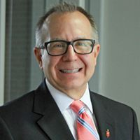

‘Either – Or’

Jan 13, 2022 | Bishop Mueller’s Daily Devo.

Social media is here to stay. I know that and so do you. In fact, it’s a technology so vast and penetrating that it literally shapes our world. Sometimes for bad. And sometimes for good. On the one hand, we have seen the destructiveness it can unleash when algorithms result in the ramping up of hate and vitriol, or it becomes so consuming – even addictive – that people are on it for hours every day. On the other hand, I love how my family can have an ongoing text group in which we keep up with each other, I can see Instagram pictures of what people I care about are up to and my grandson Henry can Facetime me even though we are hundreds of miles apart. Not surprisingly, this ‘either – or’ is like so many things in life. They can be used for good. Or they can be abused for bad. This is why your relationship with Jesus matters so much. The deeper you go with Jesus, the more you mature. The more you mature, the more faithfully you live. And the more faithfully you live, the better able you are to use things like social media for good, instead of letting them use you.

Our Mission Statement
C—Create a community of trust & faith with our neighbors.
A---Attend to the physical needs of our neighbors.
P---Proclaim the Good News of Jesus Christ to our neighbors.

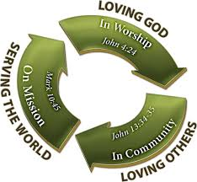
__________________________
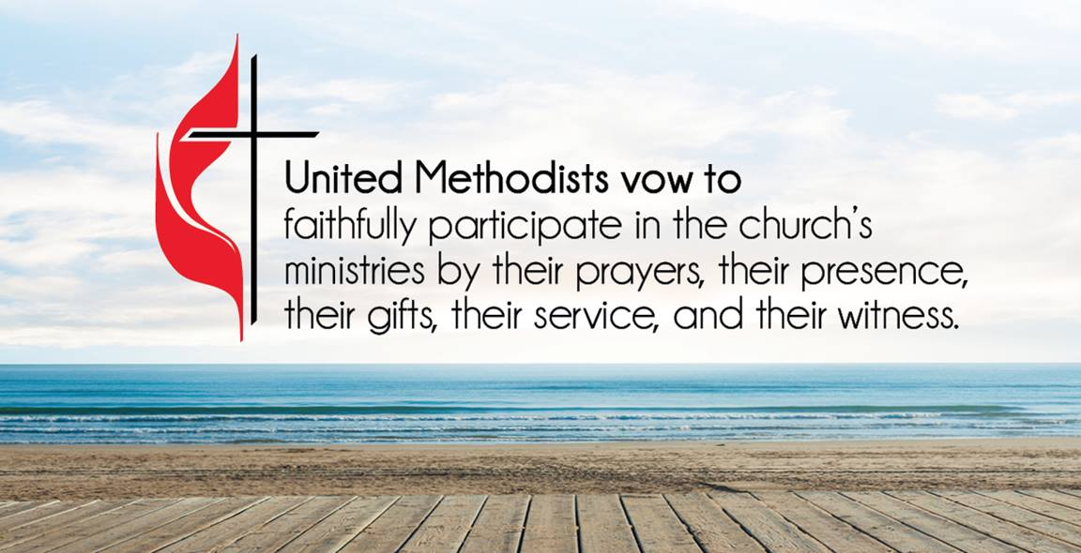
ATTENDANCE/STEWARDSHIP INFORMATION:
Sunday, January 16, 2022

Presley Chapel UMC
In Person Attendance = 0 Online Attendance = 17

General = $100.00 Building Fund = $0.00
Missions - $500.00

Huntsville UMC
In Person Attendance = 0 Online Attendance = 16

General = $600.00 Building Fund = $0.00
Missions = $0.00

How to continue supporting the church through your tithes and offerings…
Huntsville UMC:
To pay your tithes and offerings through PayPal, click on the following link: http://paypal.me/huntsvillearumc
Or, send your check to:
Huntsville UMC
P.O. Box 1257
Huntsville, Arkansas 72740
Presley Chapel:
Send check to:
Presley Chapel UMC
C/O Evelyn Ham
36872 Hwy 23
Huntsville, Arkansas 72740
______________________________

Birthdays & Anniversaries:
Presley Chapel UMC - Happy Birthday: Keagan Mount - 25, Everlea Jones - 26, Madison Tvrz - 29 Happy Anniversary: Jake & Sandy Jacobson - 23

Huntsville UMC - Happy Birthday: Travis Villines - 26, Pat Anderson - 29
Happy Anniversary: Andres & Jennifer Baez - 23

If you watch our service on Facebook, please comment or like us so that we can count your attendance.

METHODIST MEN'S CHICKEN PICK-UP:
We need your help! This is an easy way to participate in the ministries of our church. Takes less than two hours to complete. Pickup is at Tyson headquarters in Springdale at 8:00 a.m. on Tuesday mornings. Drop off at Open Arms food pantry. If you would like to help in this great cause, please click the new link and sign up or talk to pastor Ryan. https://www.signupgenius.com/go/10C0F4DAFAF29A4F4C34-chicken

______________________________

Services for this Sunday January 23, will remain online only. We will update everyone on next Sunday as soon as possible.

Our theme in our worship for this new year is to reimagine church. My hope is that this journey allows us to grow closer to God as we grow closer to each other. As Christians we require other Christians in fellowship to help recharge our batteries. Let us move forward with that in mind as we walk into 2022.

Charge Wide chili cookoff will be on February 6th, at noon at the Huntsville UMC fellowship hall.

If you would like to make a donation to help the victims of the recent tornadoes in NE Arkansas, Kentucky and surrounding states, there are 2 funds available thru the Arkansas Conference and UMCOR - Arkansas Tornado Fund or UMCOR US Disaster Response and Recovery. Please note on your check or envelope which fund you wish your donation to go to.
If you would like to be a liturgist at either church please sign up on the sheet in the back of the church. We love to have participation in our services from our laity and this is one way you can be a part of worship.
Men’s breakfast is back this month. It will be hosted by Huntsville UMC on Saturday, January 29th at 8 am. Join us for good food and fellowship.

"In the same way, the Spirit helps us in our weakness. We do not know what we ought to pray for, but the Spirit himself intercedes for us through wordless groans. And he who searches our hearts knows the mind of the Spirit because the Spirit intercedes for God’s people in accordance with the will of God."
Romans 8:26-27 New International Version (NIV)

Gary & Lisa Hull families, family, friends and HHS family of Jerick “Hutch” Hutchinson, Shannon, Barry Cleaver family, Denton & Jenettia Grubb, Truman Villines, Sharon Hargis & family, Brandi Wilkins, Kimberly Gannott, those recovering from natural disasters, Shawn, Scott & Sandra McGlocklin, Whitings great grandson, Kyler & Jeannie Scates, Barbara Smith, Joseph Turner, Kim Wickhoff, Gaye Watson, Jackie Brashears, Gabby Gillham, Kaye Doll, Beverly, Kaine Doughty, those dealing with violence, Chuck Hurburt, Sharon Daniels, Bobby Hawkins, our schools, our national, state, and local leaders, healthcare workers and all affected by COVID-19, Donald Lee & Sharon Kay Myers, Jake Jacobson, Buddy Goudeau, Mary Bergman, Les & Marlene Norton
Our Military Members: JR Lievsay, Steven Davis, Owen Davis, John Commerford, Kimberly (Commerford) Gannott

Lord in your mercy, Hear our prayers…

Please email your prayer concerns to Pastor Ryan @ ryan.bachuss@arumc.org, huntsville@arumc.org, or
presley.chapel@arumc.org.

Pastor Ryan’s prayer report:
Keep Denton and Jenettia Grubb in our prayers. Denton is back in Washington Regional. Prayers for Terry and Buddy Goudeau, Buddy is recovering from pneumonia. Kaye Doll had her last chemo treatment this week, we pray that she remains cancer free. Prayers for healing for Jackie Brashears’ hand and brain bleed as she continues rehab. Remember those who have lost loved ones. Those in rehab and nursing homes as well.

Recipe of the Week

*If you would like to submit a recipe please email to huntsville@arumc.org or ryan.bachuss@arumc.org or drop one off in person at the Huntsville office.
Hot Cocoa Mix
This makes a large enough batch to last a while.
10 cups dry powdered milk, 4 ¾ cups confectioners sugar sifted, 1 ¾ cups unsweetened cocoa powder, 1 ¾ cup powdered non dairy creamer ( I like french vanilla, but use your favorite). Mix all ingredients in a large bowl, store in an airtight container.
For 1 cup, take ⅓ cup mix and add ¾ cup boiling water. Stir to dissolve.

Children’s Corner

I hope you all got to go play in the snow this weekend. Being out of school for a few days can be fun, but Emerson starts to miss her friends and her teachers. We get used to being in a routine and when that does not go right, sometimes we get upset. Routines are great for keeping us in order, but it is also good to get away from a routine on occasion. Jesus left his parents once and they looked everywhere for him and found him teaching in the synagogue, which was a church. When they asked him why he went missing he told them he was doing his fathers work. Now I'm not recommending running away or going missing, but getting out of the boringness of a routine can be fun.

If you have an achievement that you would like to have mentioned here please let me know. We want to recognize you for your accomplishments.

Now this is a snowstorm.

Youth News!
Unless the school schedule changes, youth will meet this week but we will be following social distancing protocols.
Jumbled Thoughts
By: Pastor Ryan
What we do in life is often recorded in one way or another in today's world. Ask anyone who has had a ticket come in the mail for running a red light in some larger city. We are becoming a society that values our privacy less and less in order for us to have the conveniences that technology brings us. I do hear some people saying that they would move to a deserted island if they could and leave technology behind, but I’m sure that would be a boring lifestyle. I heard this definition a while back and it has stuck with me. Integrity is doing the right thing even when no one is looking. We face a world where someone is almost always looking. Why not have integrity every day? Live your life so that you can say that you do the right thing even when no one is watching.

Church Staff
Rev. Ryan Bachuss, Pastor
Cell: (870)-918-1145
ryan.bachuss@arumc.org

Pam Villines, Administrative Assistant
huntsville@arumc.org
presley.chapel@arumc.org
Office: (479) 738-6890

Huntsville UMC
500 W. Main, Huntsville, AR 72740
Email: huntsville@arumc.org facebook.com/huntsvilleumc
www.huntsvillepresleychapelumc.org

Presley Chapel UMC
3091 Madison 1335, Huntsville, AR
Email: presley.chapel@arumc.org facebook.com/presleychapelumc
www.huntsvillepresleychapelumc.org
Office: (479) 738-6890

